FEATURES
Communication Equipment fiber optic LC/UPC Fast Connector

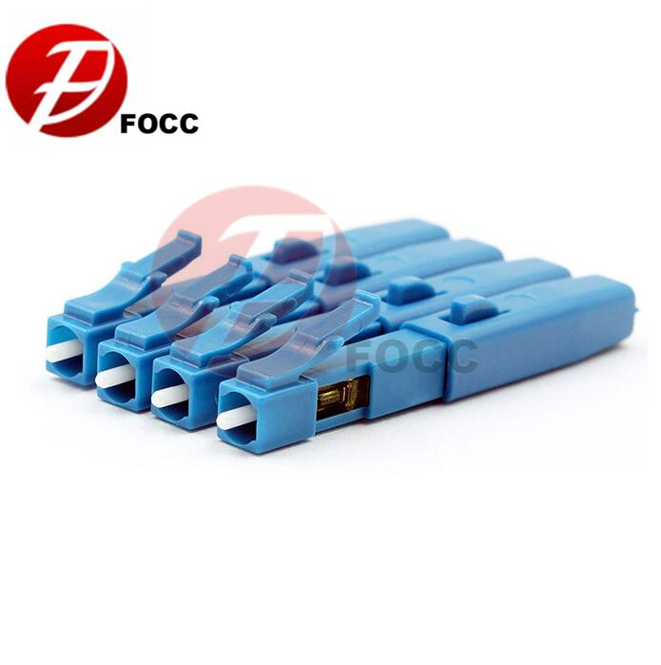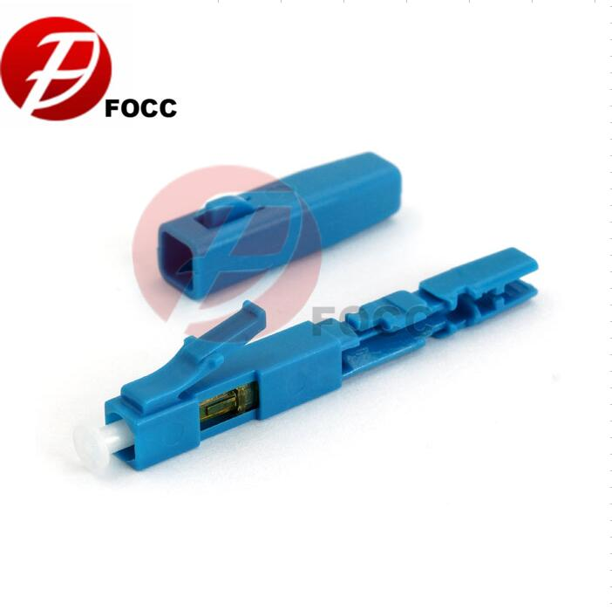
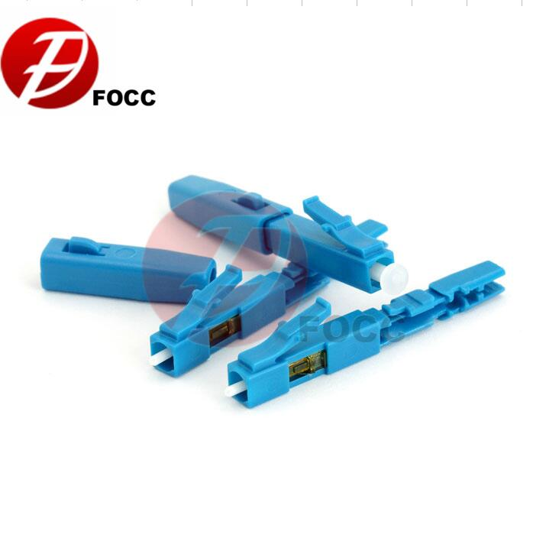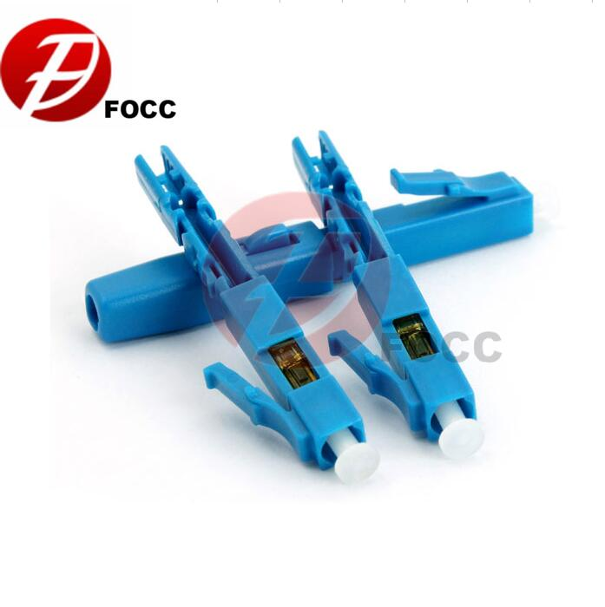
High Quality LC/UPC Singlemode Fast Connector
Fiber Optic Fast Connector make fiber terminations quick, easy and reliable. These fiber optic connectors offer terminations without any hassles and require no epoxy, no polishing, no splicing, no heating and can achieve similar excellent transmission parameters as standard polishing and splicing technology.
LC/UPC Singlemode Fast Connector is designed to simple the connection without fusion splicing machine. This connector is quick assembly which requires only normal fiber preparation tools: cable stripping tool and fiber cleaver. The connector adopts Fiber Pre-Embedded Tech with superior ceramic ferrule and aluminum alloy V-groove. Also, transparent design of the side cover which allows visual inspection.

Features & Applications
- No epoxy and polishing required
- No expensive tools required
- Quick and easy fiber termination
- Precision mechanical alignment insures low insertion loss
- Superior optical performance
- Streamlined component design, convenient operation
- Pre-installed, on-site assembly without end face grinding and consideration
- Uses proven, molded v-groove technologies
- Allow optical continuity to be verified by use of visual fault locator (VFL)
- Fiber optic communication system and telecommunication networks
- Fiber optic data transmission
- CATV
- Optical access

Technical specification
Connector Type | LC | Polishing | UPC
Ferrule | Ceramic | Fiber Mode | 9/125μm Singlemode
Cable Diameters | 0.9/2.0/3.0mm | Dimension | 50mm
Insertion Loss | ≤0.35dB | Return Loss | ≥50dB
Tension Test | ≥100N | Operating Temperature | -40°C~+75°C

Structure Example
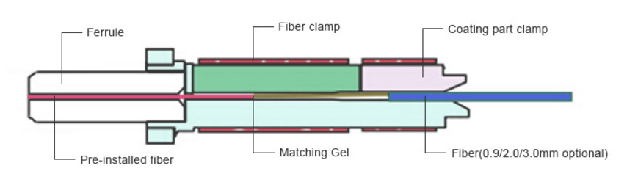
Highlights
LC/UPC Singlemode Fast Fiber Connector
- Precise attenuation values
- Low PDL & indertion loss
- Precisional reflection polishing

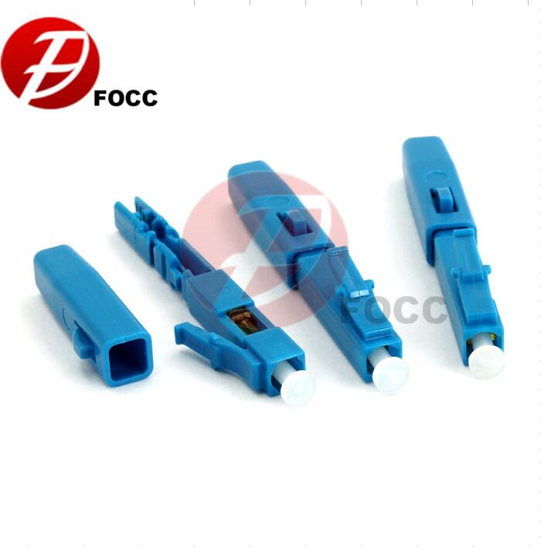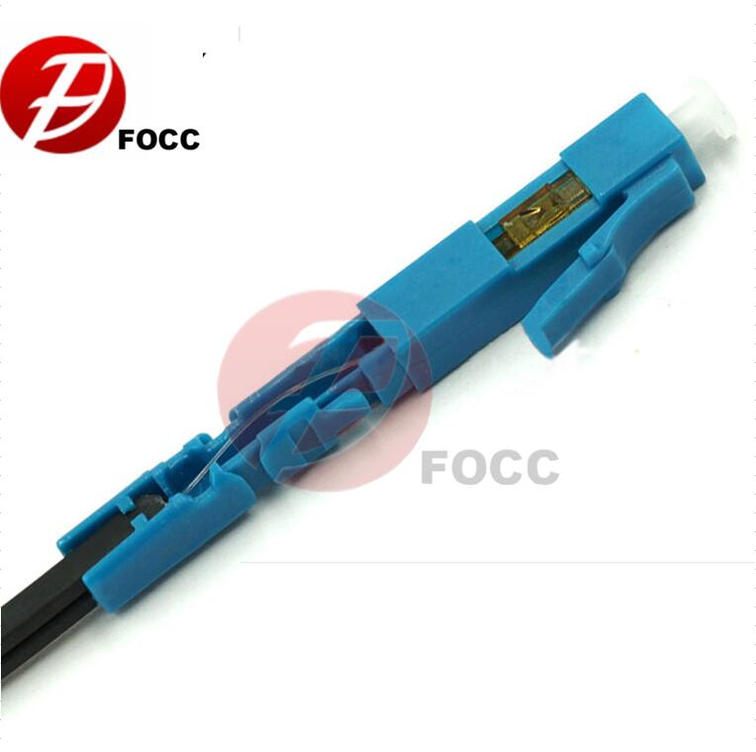
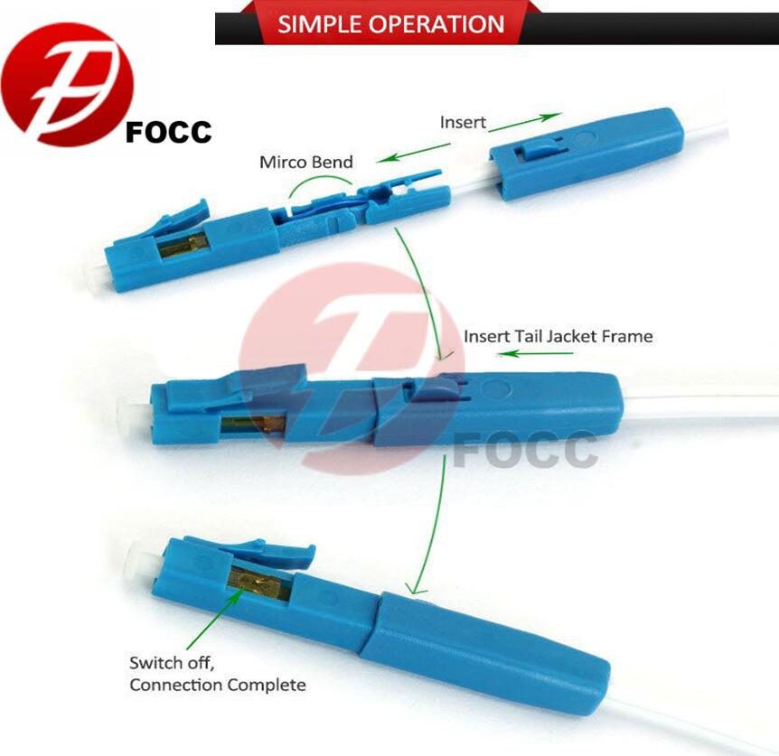
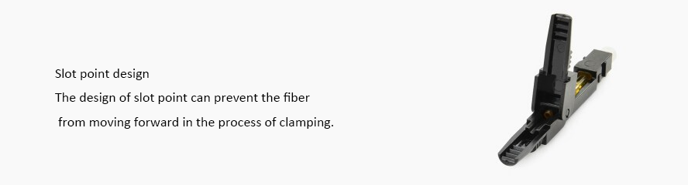
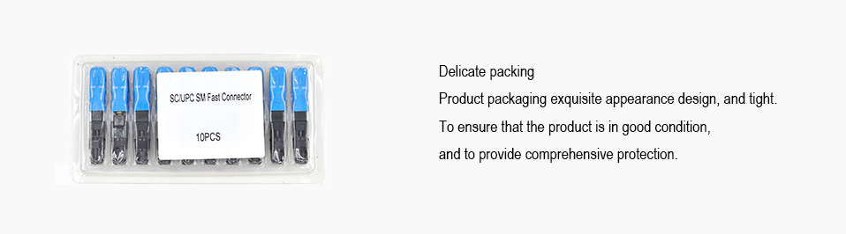
Our Service
We dedicate to customer-centric innovation and strong partnerships.
We have customer friendly warranty policy.
Our professional staffs provide 7X24- hour quickly response.
Integrity is our most valuable asset. It drives us to behave honestly and keep our promises, ultimately winning our customers' trust and respect.

Frequently asked questions
Q1:How can I get your catalogue and price list?
A1:Please let us know your email or contact us from website directly for our catalogue and price list.

Q2:Can I negotiate the prices?
A2:Yes, we may consider discounts for multiple container load of mixed goods .

Q3:How much will the shipping cost be?
A3:It depends on the size of your shipment and the method of shipping. We will offer the charge to you as you requested.

Q4:Can you supply OEM products under our brand?
A4:Yes, we are manufacturer, we accept OEM service, you just need send us your detailed requirements.

Q5: What if there is quality problem when we get the goods?
A5: If there is quality problem, you can take pictures for our reference, our QC department will check the problem and give best solutions to you, refund or return.

